**The Parts of a Computer**

**Computer Hardware:**

**CPU**:

* Today's CPUs are small and square and contain tiny pins and connectors on the bottom and is attached to the motherboard.
* CPU has two components which are the ALU (Arithmetic Logic Unit) which performs arithmetic and logical functions and the CU (Control Unit) which takes instructions from the memory of the computer and reads them using the ALU if necessary and then performs them.

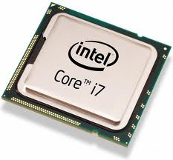

**Hard Drive**:

* The hard drive is a rectangular box. It's fairly small, about six inches long and four inches wide. In the inside, you can see a small disk, which is called the hard disk. On top of the hard disk, there is a pin that is literally 1mm above the disk. It records information on the disk.
* The hard drive stores the information that you have on the computer. It also loads the operating system of the computer.

**Video Card**: 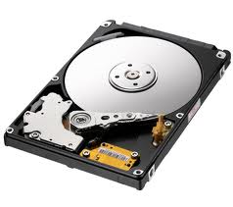

* The video card also known as the graphics card looks like a big circuit board and connects to the motherboard. Some video cards can have fans and some don’t have fans.
* The video card is a hardware that lets your computer show the images or videos that you want to see. If you are playing a game on your computer, and the games start to lag, then that means that your video card cannot relay the data of the game.

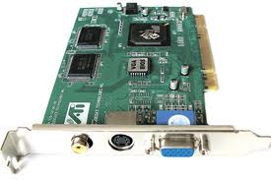

**Sound Card**:

* The sound card has the shape of the video card. On the sides it has usually two inputs. These are for either headphones or microphones.
* Again the sound card does almost the same functions as the video card. It lets you listen to your music through the computer.

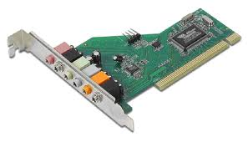

**RAM:**

* The random access memory card is connected to the motherboard of your computer. It stores the miscellaneous files of your computer. The size of a RAM can be anywhere from 120 MB to 6 GB depending on the age of the computer.

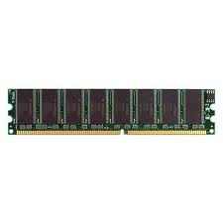

**Computer Accessories:**

**Webcam:**

* A webcam has three main parts; they are the digital camera, computer and a wire connecting the two. They are simple digital cameras that take pictures very quickly send them to other users.

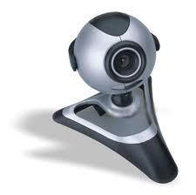

**Keyboard:**

* A keyboard is used to type on your computer. It is the next generation of the typewriter. It is one of the most important accessories of the computer.

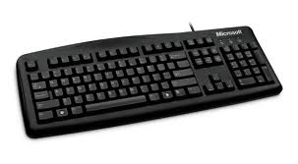

**Laptop Battery:**

* Sometimes the battery of your computer loses the ability to save power for your computer. This happens when your computer battery is old. The battery cannot hold the charge and the battery life is all of a sudden 20 minutes from 1 hour. To save your battery power you should try dimming the brightness of your screen, trying to keep the ventilation system open so your computer stays cool and don't let it be the sun's exposure because it makes the battery very hot.

